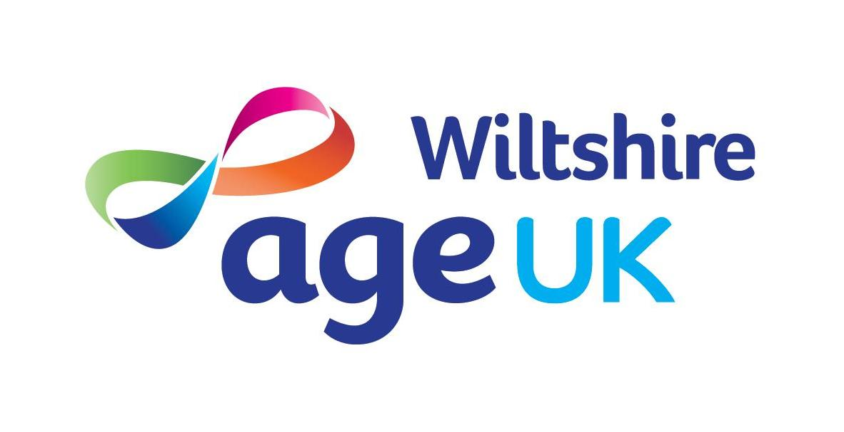
ARE YOU GETTING THE MONEY YOU ARE ENTITLED TO?



Every year, up to £5.5 billion of Pension Credit, Housing Benefit and Council Tax Benefit goes unclaimed by older people in the UK. Last year Age UK Wiltshire helped people claim over £1M of benefits that were missed out on.

If you are aged 60 or over, you could be entitled to benefits that you have not been able to claim before. These can help you keep your independence and improve your standard of living by helping with housing costs, care needs and general expenses.

If you would then like a confidential benefit check from one of our trained advisers, please telephone us on 01380 735500. We will be pleased to help you put More Money in Your Pocket.

